EVIDENCE OF NETWORK SIMULATIONS AND DATA INTERPRETATION
Document Title: Evidence of Network Simulations and Data Interpretation
Project: Cluster 6 – Darvycom Australia
Unit: ICTTEN615 – Manage Network Traffic
Prepared by: Leonardo Matias Ciarcia
Date: 04/02/2026
Version: 1.0

1. Purpose
The purpose of this document is to provide practical evidence of network monitoring, traffic measurement, congestion analysis, outage detection and recovery activities completed as part of the Darvycom Australia project.
The tests simulate network conditions relevant to the Darvycom Australia solution and demonstrate the use of appropriate network management and troubleshooting tools.

2. Simulation environment
The practical activities may be completed using a controlled test environment representing the Darvycom Australia network.
Tools used include:
- PRTG Network Monitor
- Ping
- Traceroute
- Windows network monitoring
The simulation environment allows traffic conditions and network faults to be tested without affecting a production network.

3. Test 1 – Device availability
Objective:
Confirm that PRTG can monitor whether a network device is reachable.
Procedure:
- Add the test device to PRTG.
- Configure a Ping sensor.
- Allow PRTG to collect results.
- Record response time and availability.
Result:
The monitored device showed a status of [Up/Warning/Down] with a response time of [insert] ms.
Interpretation:
The result indicates that the device was [available/unavailable] during the test period.
Evidence: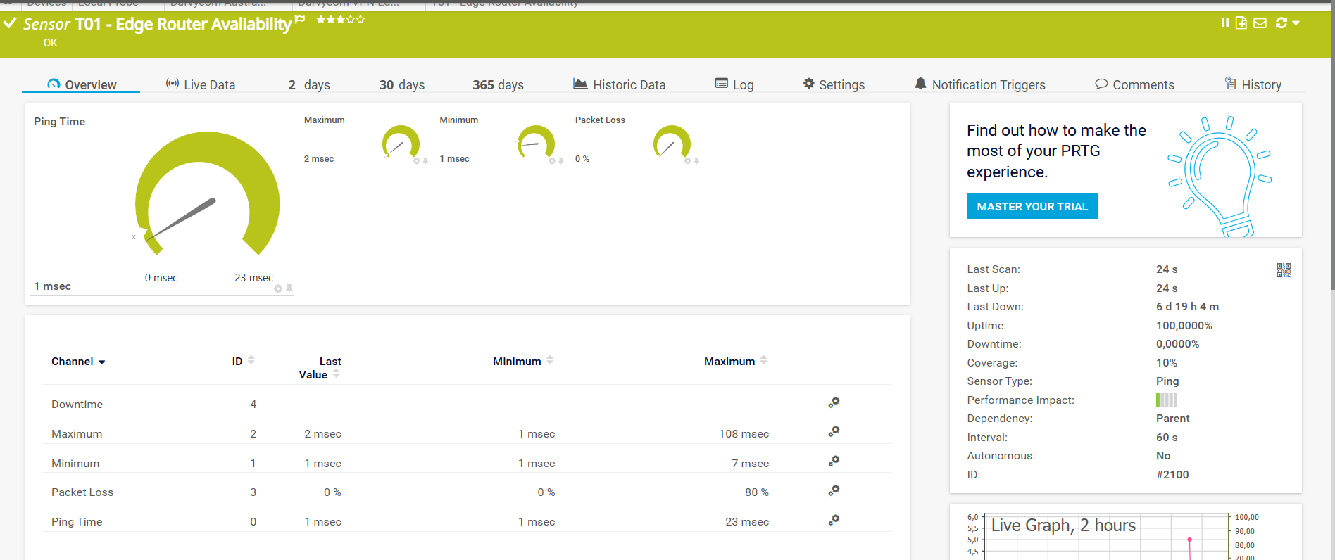

4. Test 2 – Bandwidth and traffic utilisation
Objective:
Measure traffic utilisation on the selected network interface.
Procedure:
- Configure an appropriate PRTG traffic sensor.
- Generate normal network activity.
- Record incoming and outgoing traffic.
- Compare the result with the expected baseline.
Result:
The monitored interface recorded approximately [insert] Mbps or [insert]% utilisation.
Interpretation:
The result indicates that the link was operating at a [low/moderate/high] level of utilisation.
Evidence:
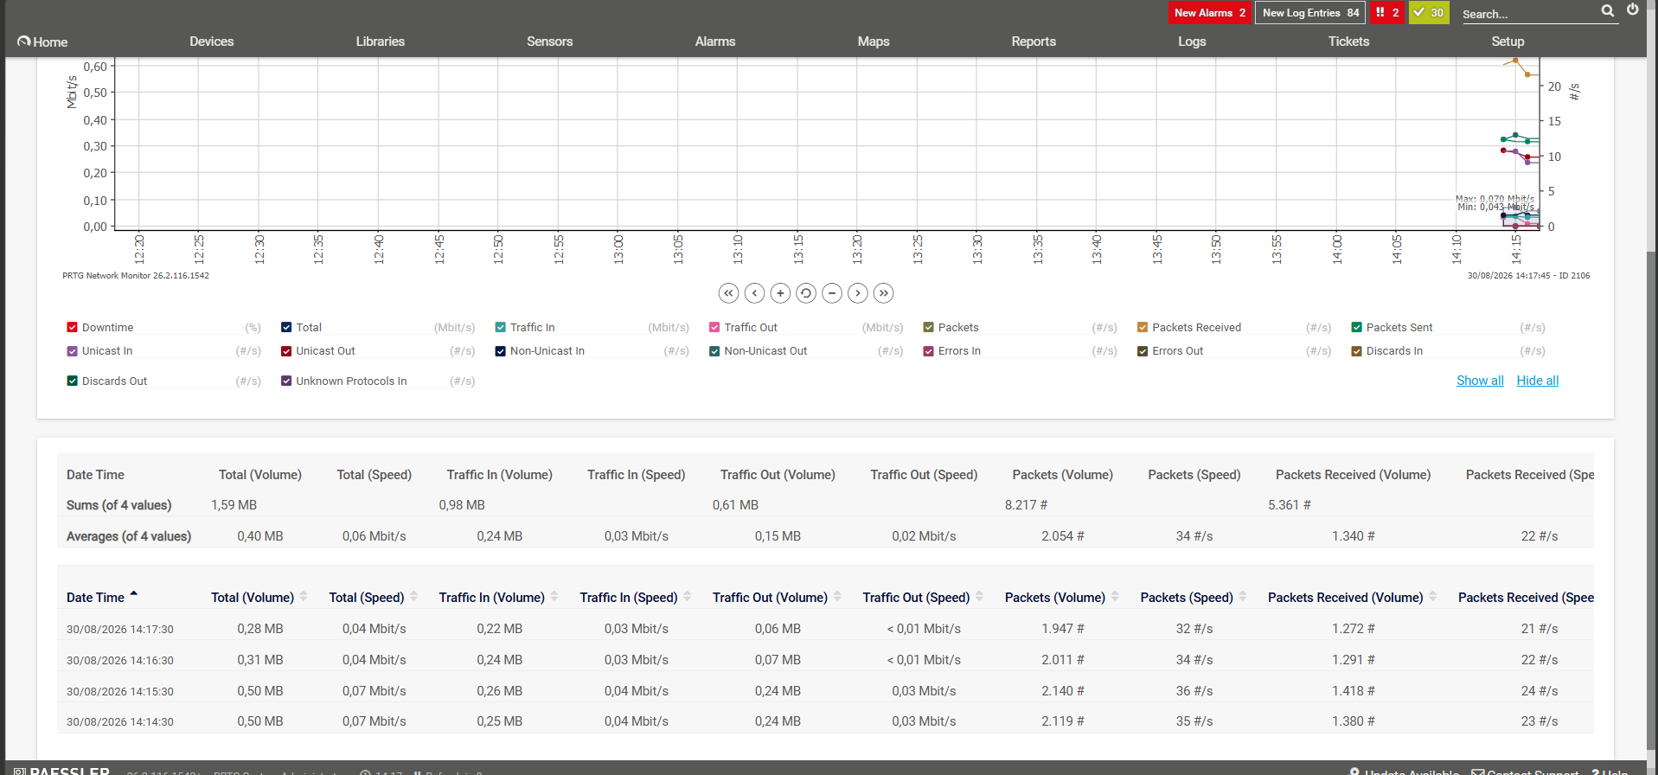

5. Test 3 – Latency and packet loss
Objective:
Measure network response time and packet loss.
Procedure:
- Run Ping testing.
- Review the PRTG Ping sensor.
- Record latency and packet-loss values.
Interpretation:
The result indicates acceptable network delay and acceptable packet loss.
Evidence:
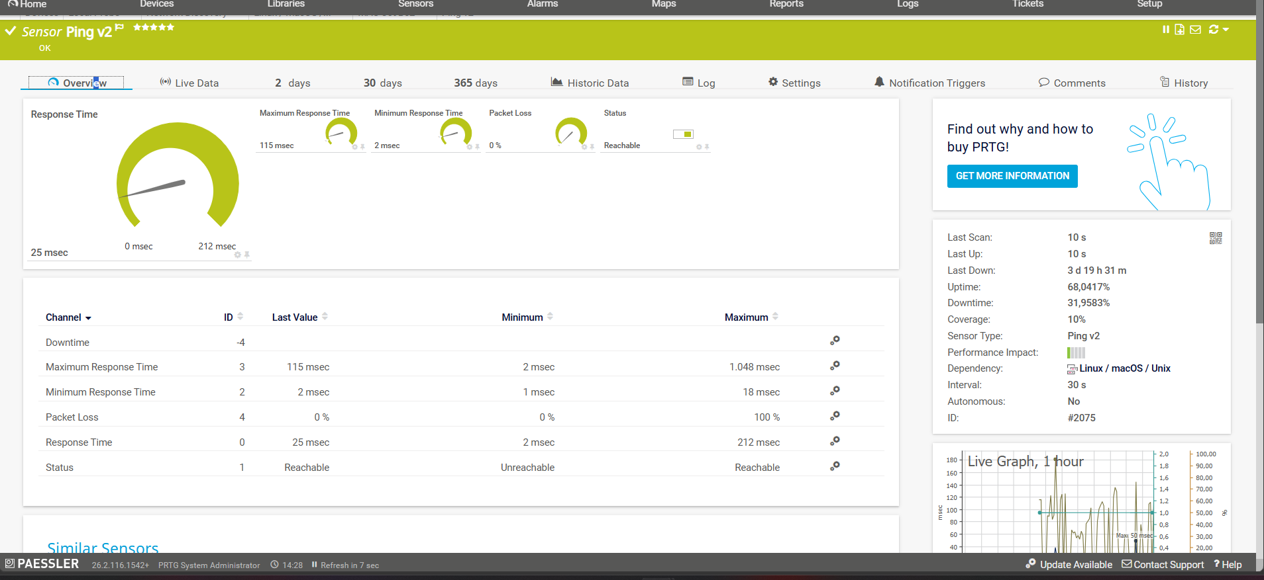

6. Test 4 – Simulated network outage
Objective:
Confirm that PRTG can detect a device or service outage.
Procedure:
- Confirm the sensor is initially Up.
- Temporarily disconnect or disable the test device/interface.
- Wait for PRTG to detect the failure.
- Record the alert and outage time.
Result:
PRTG changed the sensor from Up to down.
Interpretation:
The test confirms that PRTG can identify network unavailability and generate an alert.
Evidence: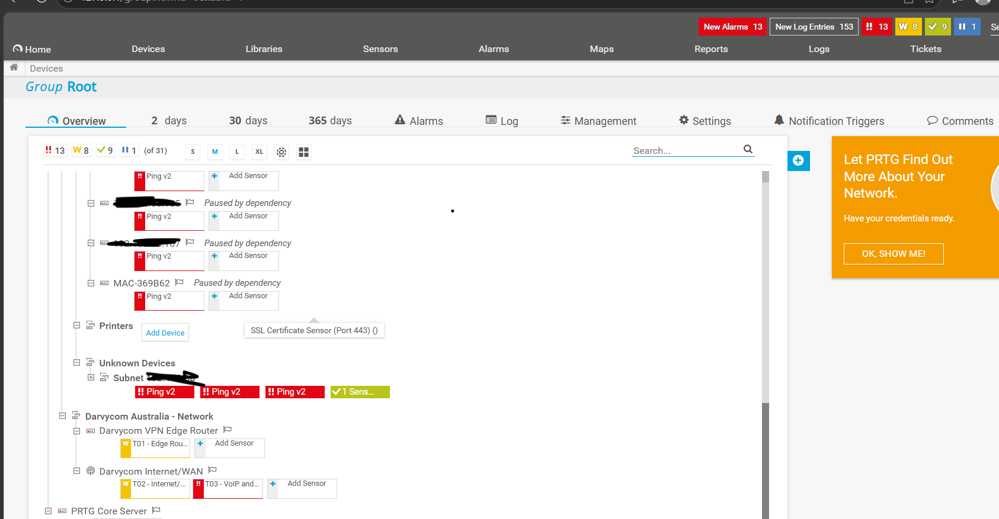

7. Test 5 – Service restoration
Objective:
Confirm that PRTG detects recovery after an outage.
Procedure:
- Restore the test device or interface.
- Confirm network connectivity with Ping.
- Wait for PRTG to return the sensor to Up.
- Record the restoration time.
Interpretation:
The test demonstrates that service restoration can be verified using PRTG monitoring data.
Evidence:
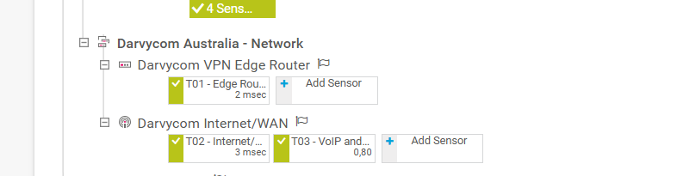[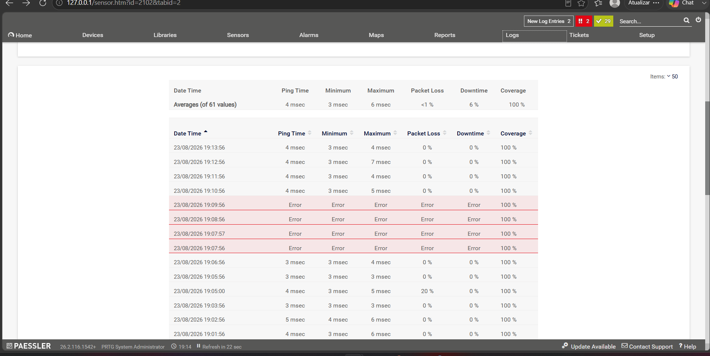

8. Test 6 – Increased network traffic
Objective:
Observe the effect of increased traffic on network utilisation.
Procedure:
- Record normal network traffic.
- Generate additional controlled traffic.
- Observe the PRTG bandwidth graph.
- Compare before-and-after results.
Interpretation:
The additional traffic caused [insert effect]. This demonstrates how increased demand can affect network capacity and performance.
Evidence:

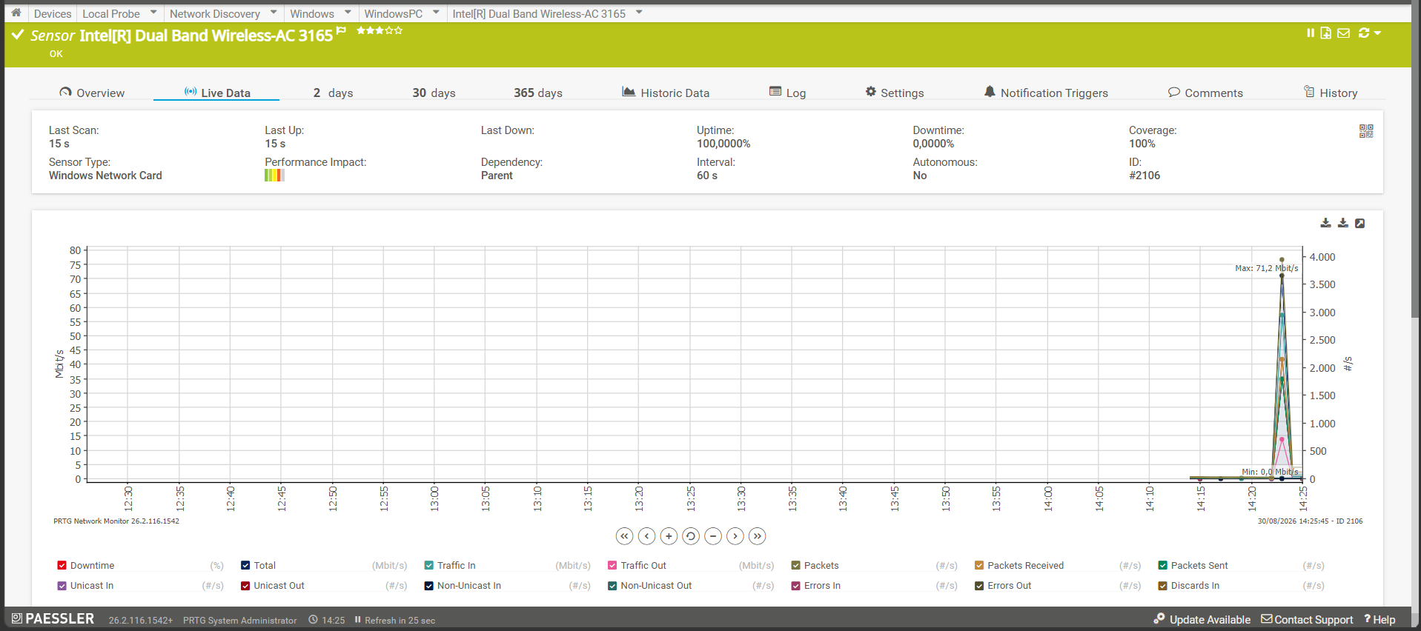9. Test 7 – Device processor utilisation
Objective:
Determine whether additional network activity affects device processing.
Procedure:
- Monitor CPU utilisation using PRTG.
- Record normal CPU usage.
- Generate network traffic.
- Record CPU usage during the test.
Interpretation:
CPU utilisation incrised, indicating that the network device was significantly affected by the additional traffic.
Evidence:

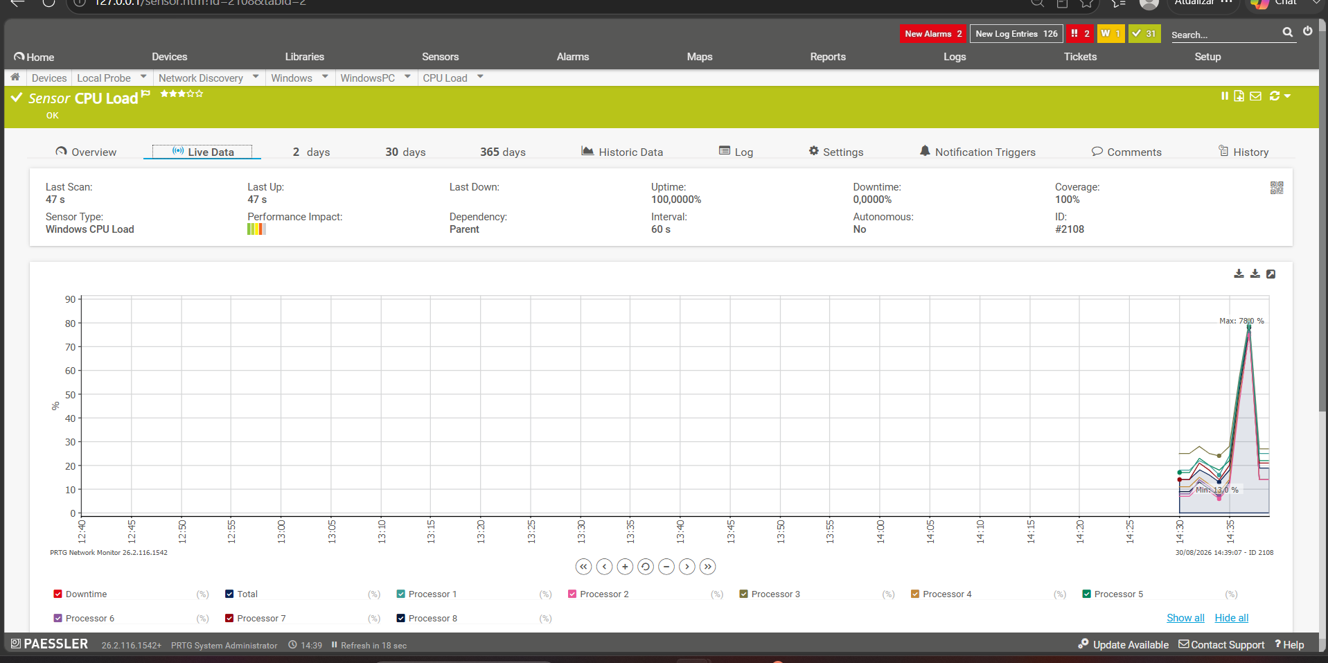

10. Test 8 – Network route analysis
Objective:
Identify the route followed by traffic between the source and destination.
Procedure:
- Run Traceroute/Tracert.
- Record the network hops.
- Identify any unusual delay or failed hop.
Result:
The test identified 30 hops between the source and destination.
Interpretation:
The route was available and no significant routing problem was identified / a possible problem was identified at 30 hop.
Evidence:
[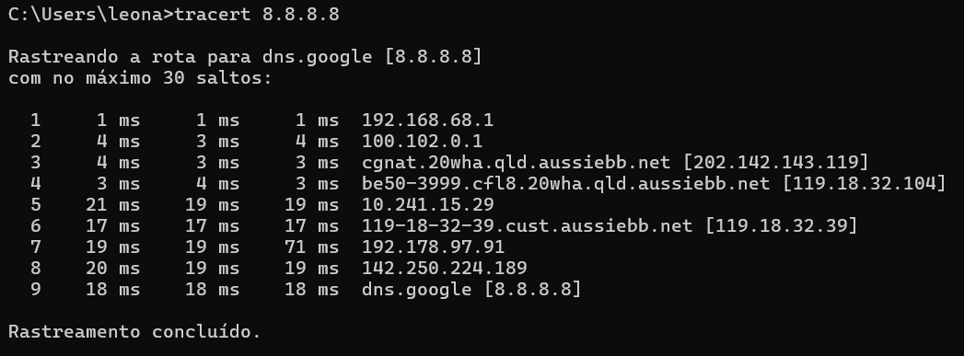

11. Data interpretation summary
The simulation results demonstrate the relationship between network traffic, capacity and performance.
High traffic utilisation can lead to increased latency, packet loss and device processing requirements. PRTG provides real-time and historical information that can assist with identifying these conditions.
The outage and recovery simulations also demonstrate how PRTG can support fault detection, restoration verification and contingency planning.

12. Findings
The practical simulations demonstrated that:
- Network availability can be monitored using PRTG Ping sensors.
- Bandwidth utilisation can be measured and compared with thresholds.
- Latency and packet loss provide useful indicators of network quality.
- PRTG can detect network outages.
- Restoration time can be verified using monitoring information.
- Increased traffic can affect network utilisation and performance.
- CPU monitoring helps identify processor overload.
- Traceroute can assist with identifying route-related problems.

14. Conclusion
The simulations provide practical evidence of traffic monitoring, data collection, congestion assessment, outage detection and network recovery.
The collected information can be used to support the traffic analysis, traffic control, contingency planning and capacity planning requirements of the Darvycom Australia project.

